Technical Report — Final Project Module 6
SATDM — Medical Device Inspector (vision + audio)
Author: Juan Carlos Aquino Hernández — Industrial Electromechanics Division, Universidad Tecnológica de Nayarit
Course: TAE-IA · Module 6 — Real-Time Deep Learning Applications, Cinvestav Guadalajara
Delivery date: October 10, 2026 (two weeks after Demo Day on 09/26/2026)
Abstract
SATDM is a Gradio medical device inspection application that, based on a photograph or video and an optional voice note from the technician, validates that the image belongs to the medical domain (gatekeeper), localizes the device (YOLOv8 trained with custom weights), classifies its type and physical status (zero-shot BiomedCLIP), generates a description in natural language (BLIP), analyzes the environmental acoustic event (CLAP), and transcribes the operator's verbal observation (Whisper). Each inspection —whether it passes the gatekeeper or not— is recorded in an auditable CSV log with a SHA-256 hash chained to the previous record, thus generating the traceability artifact that feeds the Medical Device Auditable Traceability System (SATDM) of the Nayarit Public Health Network.
Architecture
Mixed pipeline (sequential with a conditional early rejection branch):
- Input: image (photo or video frame) + optional audio (technician's voice note, via microphone or file).
- Gatekeeper: validates that the image corresponds to the medical domain (specialized YOLO with a high confidence threshold, or zero-shot BiomedCLIP as a backup). If it does not pass, the inspection is rejected and equally recorded in the log.
- Vision branch: (conceptually in parallel, executed in sequence): YOLO detects and localizes the device; BiomedCLIP classifies device type and physical status; BLIP generates a natural language description.
- Audio branch: the audio is normalized to a common contract (mono, float32, target sample rate); CLAP classifies the acoustic event (alarm, engine, voice, environment, silence) in a zero-shot manner; Whisper transcribes the voice if present.
- Output: a text report that integrates device type, status, acoustic event, voice transcription, and visual description; optionally narrated with XTTS (disabled by default).
- Traceability: each inspection (whether it passes or fails the gatekeeper) is written to a CSV log with a SHA-256 hash chained to the previous record, plus an evidence JSON with the full details of each model.
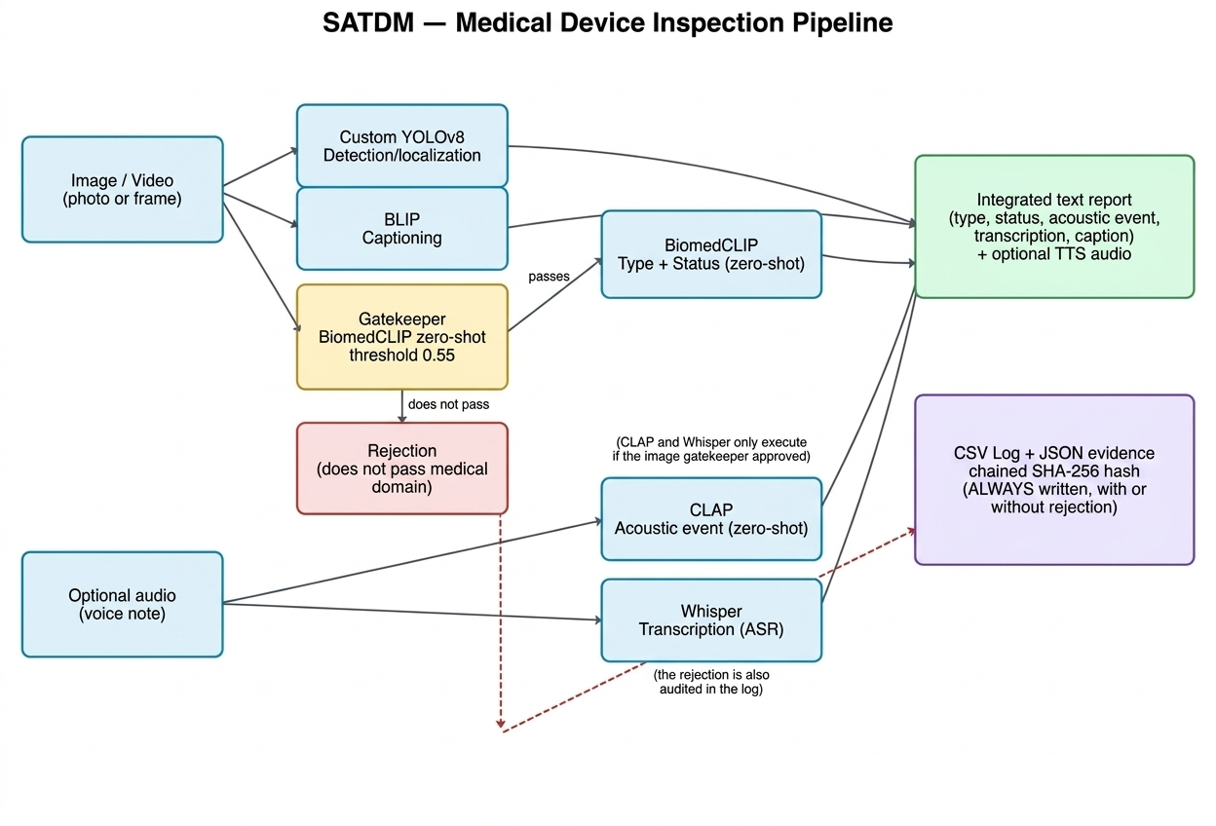
Figure 1. SATDM Pipeline: YOLO and BLIP always run on the image; BiomedCLIP acts as a medical domain gatekeeper and, if it approves, also classifies type/status; CLAP and Whisper process the audio only if the gatekeeper approved the image; everything is integrated into the report and audited in the log, including rejections.

Models Used and Justification
Model | Task | Size / VRAM | Why this one and not another
YOLOv8  (custom or fallback yolov8n) | Object detection | Variant unconfirmed in the file name (pesos_medicos_yolov8.pt); YOLOv8n is around 3.2M parameters, YOLOv8s is around 11.2M (public figures from Ultralytics). In the reference run with GPU (T4, 15.6 GB total), the 5 models together (YOLO+BiomedCLIP+BLIP+Whisper+CLAP) occupied 2.86 GB of VRAM as a whole — individual breakdown per model was not measured. | Fast detector in real time; custom version trained on a proprietary dataset of medical devices (Roboflow).
BiomedCLIP  (open_clip, zero-shot) | Classification (device type and status) | ≈195M parameters combining the ViT-B/16 image encoder (~86M) and the PubMedBERT-256 text encoder (~110M), according to the public model card on Hugging Face. See combined VRAM note in the YOLO row. | Zero-shot on the biomedical domain avoids having to train a supervised classifier for each new device category or status.
BLIP  (blip-image-captioning-large) | Captioning / visual description | Salesforce/blip-image-captioning-large: ≈470M parameters according to the public model card. See combined VRAM note in the YOLO row. | Generates a natural language description that complements the structured classification, useful for the human-readable report.
CLAP  (laion/clap-htsat-unfused, zero-shot) | Acoustic event classification | laion/clap-htsat-unfused: ≈153M parameters according to the public model card. See combined VRAM note in the YOLO row. | Allows adding/editing event categories (alarm, engine, voice, environment) without retraining, same as BiomedCLIP for vision.
Whisper  (openai/whisper-small) | Voice transcription (ASR) | openai/whisper-small: 244M parameters (public OpenAI figure). See combined VRAM note in the YOLO row. | Balance between accuracy and speed to transcribe the technician's voice notes in Spanish within the time frame of an inspection.
XTTS v2  (optional, ENABLE_TTS) | Report speech synthesis | ≈467M parameters (public Coqui figure). Does not run in this configuration (ENABLE_TTS=False). | Disabled by default (ENABLE_TTS=False): the audio requirement is already met with CLAP+Whisper at the input; documented as a future extension.
Compliance with requirements: 3 vision models with different tasks are used (detection, classification, captioning) — exceeding the required minimum of 2 — and audio is processed at the input with two models (CLAP and Whisper), the result of which is explicitly reflected in the report delivered to the user.
Implementation
Memory Management
The five models (YOLO, BiomedCLIP, BLIP, Whisper, CLAP) are loaded only once into global variables at the beginning of the notebook (Section 3) and reused in each Gradio call; they are not reloaded per inspection. All inference functions (clip_zero_shot, describe_image, transcribe_audio) are decorated with @torch.inference_mode() to prevent the accumulation of autograd graphs. Precision is set dynamically with DTYPE = torch.float16 if DEVICE == 'cuda' else torch.float32. Two real runs were documented: one without a GPU assigned by Colab (DEVICE='cpu', all models in float32, working correctly although slower) and another with a T4 GPU (DEVICE='cuda', 15.6 GB total VRAM), where the self-diagnosis recorded a real and measured consumption of 2.86 GB of VRAM after loading the 5 models together ([VRAM] 2.86/15.6 GB — Integrated SATDM models loaded).
Formats and Preprocessing
- Image: forced to RGB, minimum/maximum size (MIN_SIDE/MAX_SIDE) is validated, and it is rescaled if it exceeds the maximum allowed.
- Audio: always converted to mono float32; resampled to the rate required by each model (48 kHz for CLAP, 16 kHz for Whisper); truncated if it exceeds the maximum duration and rejected if it is too short.
Issues Resolved and Methods
- The gatekeeper's medical domain threshold was set to MEDICAL_THRESHOLD = 0.55 on the sum of zero-shot probabilities of BiomedCLIP's medical labels; higher values rejected medical photos taken with poor framing, while lower values let everyday objects pass.
- Classification ambiguity (type or status) is measured with normalized entropy and flagged for manual review when it exceeds AMBIGUITY_ENTROPY = 0.85, as well as when confidence falls below MEDICAL_THRESHOLD.
- For YOLO, if the specialized weights are not found in Google Drive (pesos_medicos_yolov8.pt), the system automatically falls back to generic yolov8n.pt (COCO) as a backup localizer without stopping the app.
- Image size is bounded between MIN_SIDE = 64 and MAX_SIDE = 1280 px to discard useless crops and avoid excessive rescaling.
- Audio is always normalized to mono float32 before any model (common audio contract), with CLAP_SR = 48000 Hz for CLAP, duration between AUDIO_MIN_SECONDS = 0.5 and AUDIO_MAX_SECONDS = 60 s, and a confidence floor of AUDIO_CONF_FLOOR = 0.55 below which the acoustic event is reported as 'non_conclusive' instead of forcing an unreliable label.
Results(app gravio.live for cel.)
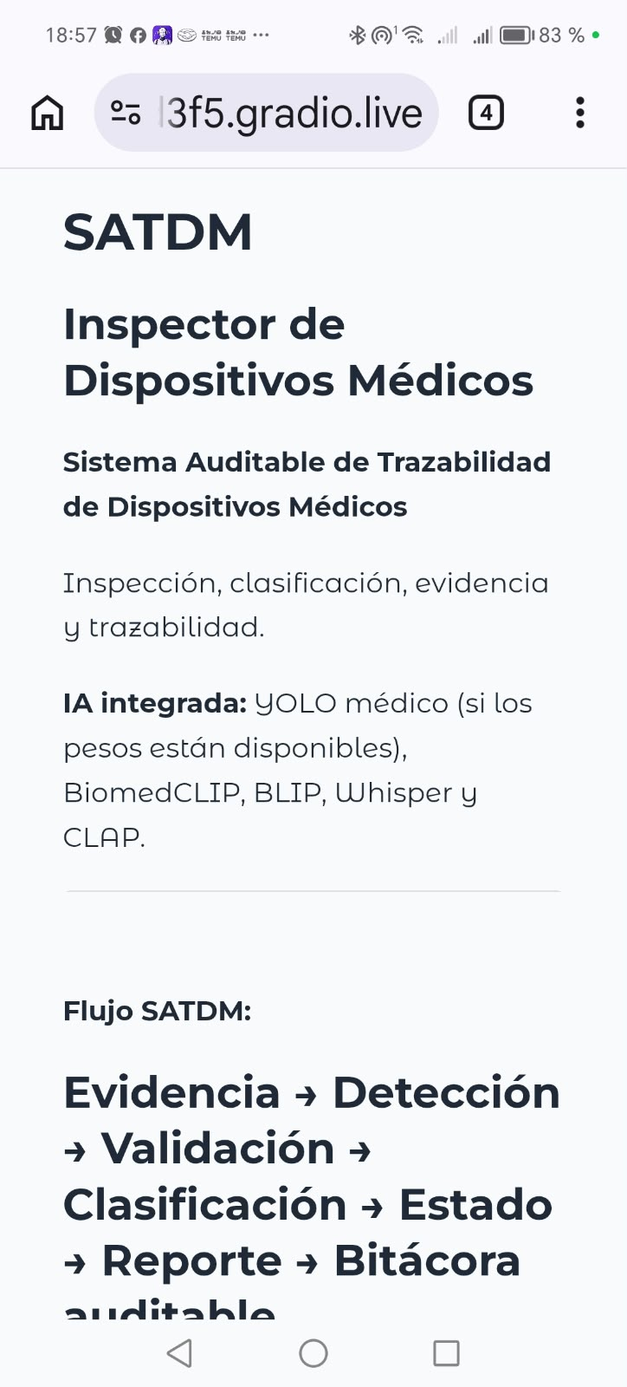 | 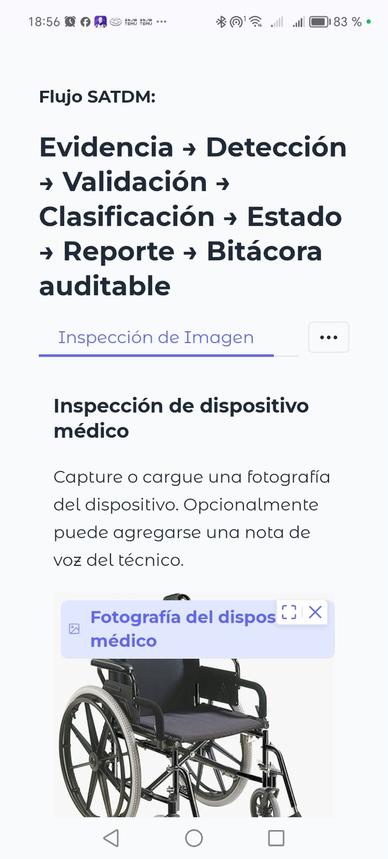 | 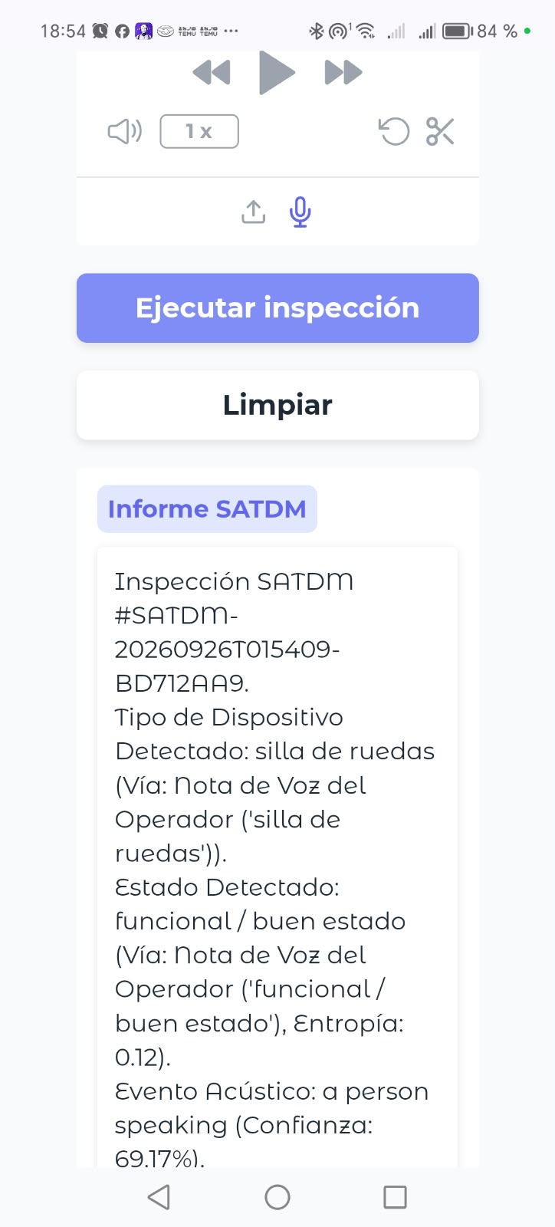

Ledger Integrity Verification (Real Evidence)
A real cryptographic audit was run against the production log (inspecciones_log.csv), initially with 23 records and, after fixing the schema, with 28. The process uncovered and fixed two design defects in the verification script itself (not in chain generation): (1) the initial verifier compared against the wrong column (evidence_sha256, the image hash, instead of record_hash, the actual chain link) and used a recomputation algorithm different from the one in append_ledger; (2) reconstructing types from the CSV (booleans, empty values) was not reliable enough to reproduce the exact hash, since CSV is a typeless format. The adopted fix was to persist, as a new column canonical_payload, the exact canonical JSON string that append_ledger hashes when creating each record, and to verify by re-hashing that stored string directly instead of reconstructing it. After applying the fix (with automatic schema migration via cell 2b, backup .bak preserved), the final audit result was:
[*] Starting cryptographic audit on ‘inspecciones_log.csv’ (28 records found)...
[+] AUDIT STATUS: SUCCESSFUL. Chain linkage verified for all records.
[i] Note: 23 record(s) predating the ‘canonical_payload’ schema were only verified by chain linkage, not by content.
The 23 records generated before the fix remain verified by chain linkage (insertion, deletion, or reordering cannot occur without being detected), but not by exact content, since the original canonical string was never persisted — an acknowledged design limitation, not an active vulnerability. Records 24 onward (generated after the fix) were successfully verified both by chain linkage and by exact content (byte-for-byte match between the hash recomputed from canonical_payload and the stored record_hash), confirmed specifically on the last record of the run (SATDM-20260926T013336-68D622D8).
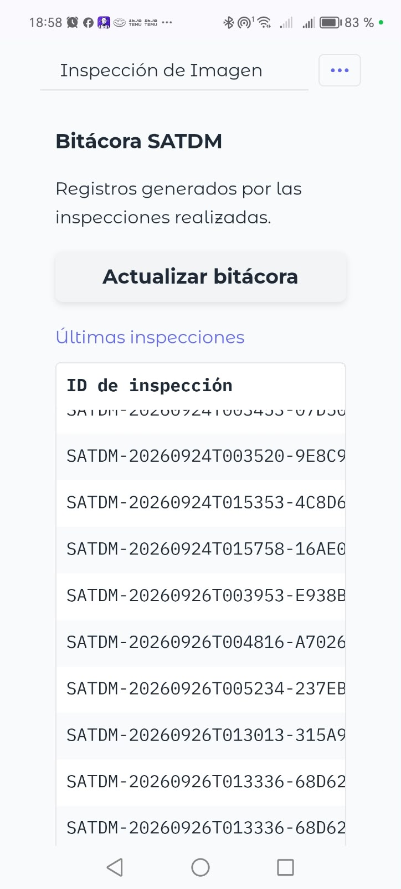 | 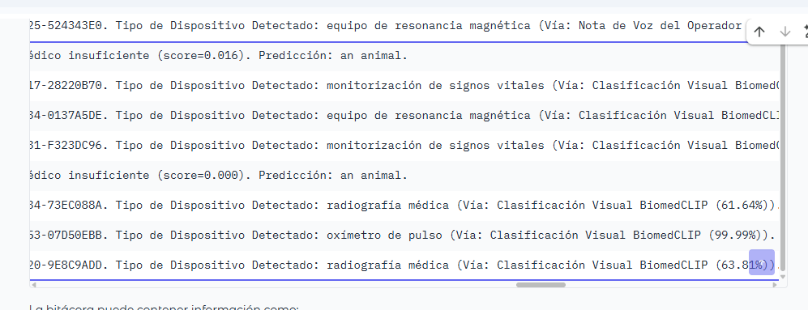

Failure Cases
Minimum of 5 documented cases, specifying input, root cause, and mitigation. IMPORTANT NOTE: the 5 cases in the table below are written as predictions based on the code (actual thresholds, templates, and pipeline logic), NOT as already confirmed observations — before handing in the report, each row must be replaced or confirmed with the actual input used, the actual output obtained, and screenshot evidence; a documented failure case requires evidence, not just a reasonable hypothesis.
Specific Input | What Went Wrong | Cause | What Was Done / Would Be Done
Photo of a medical device taken from very close range (crop < 100 px per side), just above the minimum MIN_SIDE=64 | Type classification with high entropy / unstable label between runs (hypothesis to be confirmed with real test) | MIN_SIDE=64 is permissive: it lets through crops with almost no visual context, which are insufficient for BiomedCLIP to distinguish between type templates with similar appearance (e.g., monitor vs. infusion pump from a side profile). | Raise MIN_SIDE or require a second validation of relative size to the full frame before classifying.
Photo with dark spots or intense shadow on the device housing | Status classified as 'visible corrosion or oxidation' when it is actually 'visible dirty or contaminated' (or vice versa) | The text templates for both statuses in STATUS_TEMPLATES describe visually close appearances (dark spots) and zero-shot BiomedCLIP was not fine-tuned with real images of damaged medical devices. | Expand templates with more discriminating vocabulary (color, texture) and/or collect a labeled validation set from the log itself to measure the actual confusion matrix between these two statuses.
Voice note recorded with hospital ambient noise (alarms, background conversation) with low signal-to-noise ratio | Whisper incorrectly transcribes status keywords, and the voice override is neither activated nor explained | detect_device_from_voice and voice-based status detection depend on exact substring matching against VOICE_DEVICE_KEYWORDS / status keywords; a Whisper transcription error silently breaks the match. | Record in the report when a voice match was attempted but not found (instead of just silently falling back to visual classification), and/or use fuzzy matching instead of exact substring matching.
Audio clip of the device itself close to the confidence floor AUDIO_CONF_FLOOR=0.55 (e.g., an engine recorded from a distance) | The acoustic event oscillates between a real label ('a motor or pump running normally') and 'non_conclusive' between runs | Being right at the threshold, small variations in recording levels push the CLAP score to both sides of the fixed floor, with no indication of a 'near miss' in the report. | Also report the numerical CLAP score in the text report (not just the label), so the technician knows if the result is a marginal boundary.
Video with two devices of the same type (e.g., two beds) briefly crossing paths in the frame, processed with ByteTrack | The track loses ID and restarts as a new track, losing the accumulated history of type_scores/state_scores | ByteTrack reassigns IDs when two boxes overlap or one is occluded for several frames; the memory[tid] dictionary of inspect_video does not merge tracks that are actually the same physical object. | Add a reconciliation heuristic based on position/IoU when a track is lost, or accept the limitation and document it as out-of-scope for production.
Ethics
Misuse Scenarios (minimum 2)
- Status Falsification: a technician under time pressure photographs a different (functional) device instead of the one that is actually damaged, so that the gatekeeper and BiomedCLIP report 'functional / good condition' to avoid the equipment removal process, thereby hiding a real failure from a subsequent audit.
- Voice Cloning Without Consent: if ENABLE_TTS were activated, XTTS could be used with a REFERENCE_VOICE recorded without authorization from a specific technician, generating narrated reports that sound as if that person dictated them, without their actual participation in the inspection.
Guardrails Implemented
The log is append-only with a SHA-256 hash chained to the previous record (record_hash / previous_record_hash), so altering a past record breaks the chain and is detectable; each approved or rejected inspection is always audited (there is no way to 'leave no trace'); the review_required field triggers automatically when confidence drops below MEDICAL_THRESHOLD=0.55 or entropy exceeds AMBIGUITY_ENTROPY=0.85, forcing human review in ambiguous cases; XTTS is disabled by default (ENABLE_TTS=False), avoiding the voice cloning scenario by design unless explicitly enabled with additional safeguards.
Unresolved Issue
The system does not verify that the device_id (hash of the detected device type) corresponds to a specific physical device registered in the hospital inventory, nor does it authenticate who executes each inspection: the log proves that 'someone' registered 'something' at a certain time with certain visual evidence, but it does not cryptographically link that inspection to the operator's identity or the equipment's actual serial number — the misuse scenario from the previous section (photographing the wrong device) is not prevented by the system as it stands; it is only recorded in an auditable manner for a human review to detect later.
Reproducibility
- Fixed Seeds: SEED = 42 applied to random, numpy, and torch (including CUDA) at the beginning of the notebook.
- requirements.txt included in the project ZIP file.
To run from scratch in a new Google Colab runtime:
- Mount Google Drive and place pesos_medicos_yolov8.pt in <Drive>/TAE_IA_M6/ (if missing, the app automatically uses generic yolov8n.pt as a backup without stopping).
- Execute the notebook cells sequentially from top to bottom (Setup → Configuration → Models → Taxonomies → Utilities → Inference → Image/Video Inspection → Interface).
- Execute the last cell, app.launch(share=True, debug=True), and open the public URL printed in the console.
- To stop, interrupt the cell (Ctrl+C / stop button), which safely closes the Gradio tunnel.
Conclusions
- What worked well: the zero-shot approach (BiomedCLIP + CLAP) allows covering type, status, and acoustic event without the need to train supervised classifiers for each category, and the chained-hash log provides actual auditable traceability from the first execution.
- What did not work well / was corrected during development: a label outside the domain ('female doctor') contaminated the device type classification by both image and voice, the coverage of statuses recognizable by voice was incomplete (only 3 out of 7), the confidence of decisions made by voice was fixed at 1.0 (which could artificially suppress manual review), and the video pipeline was less rigorous than the image pipeline in its review_required criteria.
- With more time, we would: build a labeled validation dataset from the log of actual inspections to measure with numbers (not just hypotheses) how well BiomedCLIP distinguishes visually similar statuses (dirty vs. corrosion); unify the acoustic analysis (CLAP) into the video path as well, which currently only uses it in the image path; and add operator authentication to the log to close the ethical gap documented above.

